What is it an Autonomous Vehicle?

An autonomous vehicle, or ‘self-driving car’, is a vehicle with the capability of moving safely with little to no human input whatsoever.   
While most cars currently in production have some basic levels of automation through features such as cruise control, lane assist technology, park assist and automated braking, the requirement of human interaction is still the major aspect of controlling the vehicle. As technology is developing however less and less human interaction is being required, from the early stages of a driver being able to relinquish control but still maintaining awareness to take over if needed, to fully automated vehicles where control can still be accessed but is not required.

Achieving Automation

To achieve automation a vehicle must utilise a variety of sensors, actuators, machine learning systems and software to create and maintain maps of their surroundings.

* Radar sensors monitor the position of nearby vehicles.
* Video cameras are utilised to detect traffic signals, other vehicles, and pedestrians.
* Light detecting and ranging (LIDAR) sensors measure distances, detect road angles and monitor lane markings.
* Ultrasonic sensors in wheels are utilised to detect curbs and other cars whilst parking.

All of these are used to create instantaneous data, which is then processed by advanced software, sending instructions to the cars actuators controlling speed, braking and direction.  
The software’s instructions are dictated by a set of rules, avoidance algorithms, object recognition, and predictive modelling which help the software operate within the law and avoid possible obstacles. (What is an Autonomous Car? – How Self-Driving Cars Work | Synopsys, 2020)

Current Levels of Automation

While many leading developers in autonomous vehicles can now currently achieve a level of automation where a driver is only required to react to unusual circumstances this can only be achieved along predefined routes and under specific circumstances (weather, day time etc..). These companies can offer automated shuttle buses for their employees, however with still the need for a safety driver on board. (The Current State of Autonomous Vehicles, 2020)

The level of automation readily available to the public is currently not at that level, however recent advancements in technology have progressed manufacturers towards the ability of having simultaneous driving functions being automated.

A leader in this field is Cadillac’s Super Cruise system as it is one of the only ‘hands-free’ driving systems available to the public. For this particular system to be utilised the car must be on a pre-mapped highway under appropriate conditions while the driver remains attentive to their surroundings, the car will control speed, braking, and lane keeping. In the event that the car cannot access any of the sensors correctly or any cameras are impeded by poor weather or light the system will not be accessible, furthermore if the driver is to be deemed inattentive by the ‘Driver Attention Camera system’ the car will display several warning before slowly coming safely to a halt on the side of the road if no action is taken.  
It is recommended that the system is not to be used under difficult driving conditions including inclement weather and poor visibility. (Super Cruise: Hands-Free Driving, Cutting Edge Technology, 2020)

Future Levels of Automation

The Society of Automotive Engineers has (SAE) has defined six levels of driving automation.

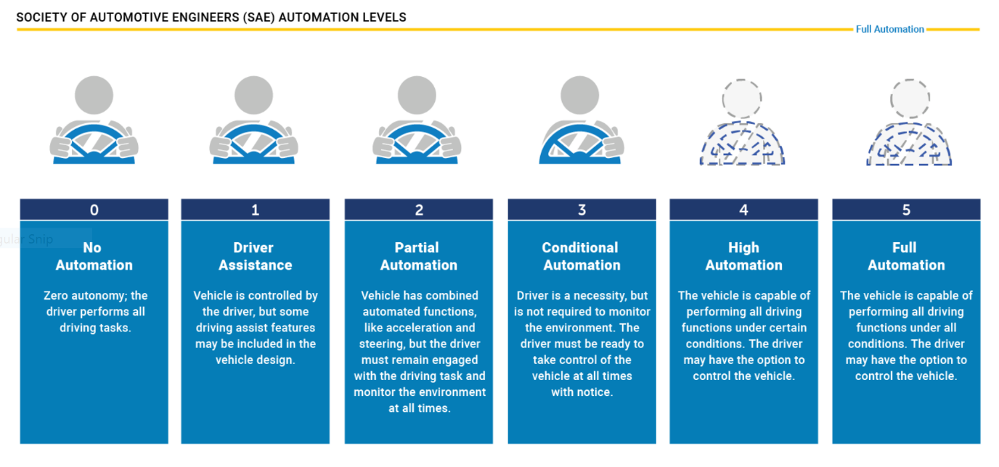

(Automated Vehicles for Safety, 2020)

While we are currently able to say that level three of automation is indeed a reality with the current use of ‘environmental detection capabilities’, level four is already in its early stages.

The key difference between level three and four will be the vehicles ability to make decisions and intervene in the instance of something going wrong or a system failure, meaning that a car does not require human operation however can still be overridden in certain circumstances.  
Level four vehicles will be able to operate in a complete self-driving mode, which although currently achievable in limited designated areas (geofencing), requires evolution of current legislation and infrastructure to allow wide spread use.

Level five automation will require zero human interference, eliminating the need for steering wheels, pedals and geofencing. This will however be some time away.

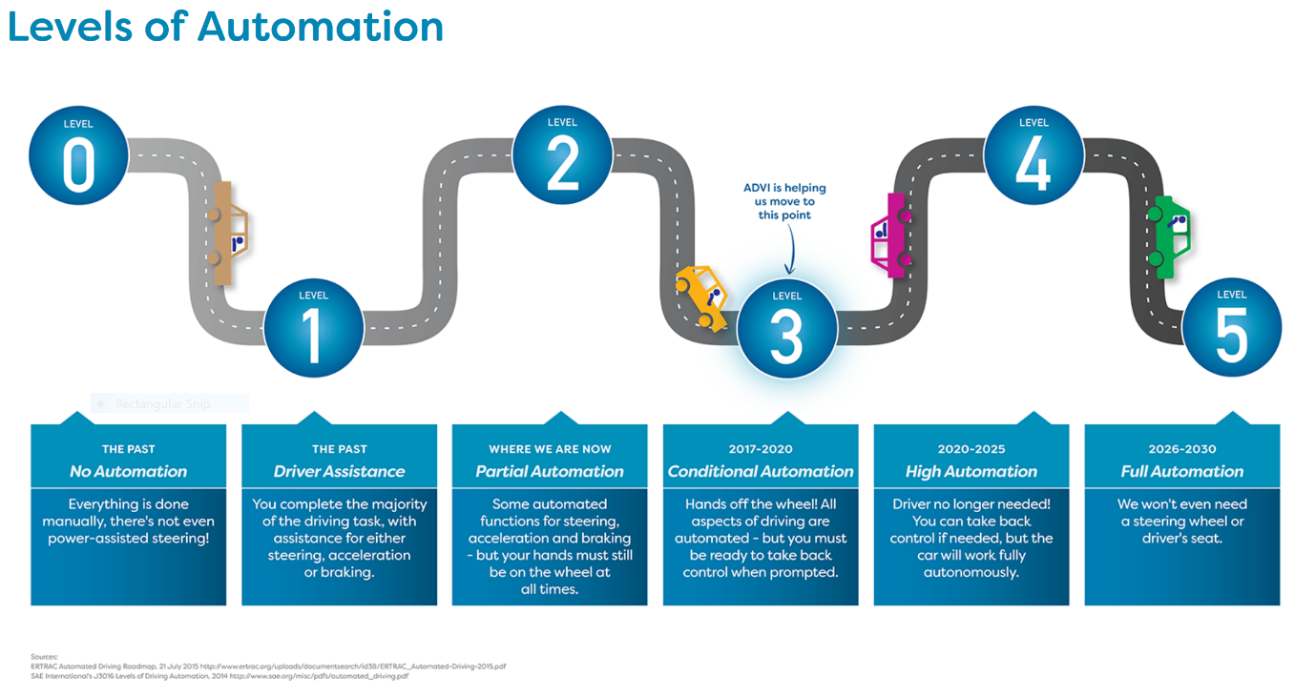

(What is a driverless car? | ADVI | Autonomous Vehicles, 2020)

What is the Likely Impact?

The potential impacts of successful automation are profound in many different regards from both a traditional sense but also from a business sense.  
The immediate and perhaps most pressing issue with driving today is the safety aspect. 94% of serious traffic accidents are caused by human error (Automated Vehicles for Safety, 2020). Automation has the possibility to eliminate human error from an incident and potentially save lives on the road. One possible problem with this though is the moral dilemma of who lives and dies in an unavoidable accident, a decision must be made how to regulate and write the software that will make these decisions.  
Another benefit will be the ability for those impeded by ailments such as blindness, epilepsy, etc to commute a lot more freely as the automation will allow them to access cars that they were once not allowed or able to drive. This will also be true of people that once could, but no longer, operate a motor vehicle such as the elderly or somebody who has developed a disability after birth.  
  
From a business standpoint autonomous vehicles will have a major impact on everyday services such as taxi/ridesharing use, public transportation, and delivery services (both short and long haul). While the timing of the impact to each specific industry will be different, many level four vehicles already in existence have been geared to ridesharing within geofenced areas (The 6 Levels of Vehicle Autonomy Explained | Synopsys Automotive, 2020), there will be definite implications to skilled driving services as automation becomes more prevalent. Skilled bus and truck drivers will be replaced by autonomous vehicles designed to do the same job and taxi/ridesharing drivers would no longer be needed should ridesharing companies embrace autonomous vehicles.

How Will this Affect You?

On a personal level, autonomous vehicles will have the potential to alter our everyday lives in multiple ways.

* Congestion will ease on major motor ways reducing travel time.
* Automation will have the ability to reduce the risk of accidents lowering insurance premiums and repair costs, this will have a large impact on personal budgets.
* Reduced cost and wait time of public transport and taxi/ridesharing services.
* Reduced stress and anxiety caused by the thoughts and actions of operating a motor vehicle in difficult conditions or scenarios.

The development and implementation of autonomous vehicles will also affect society as a collective greatly. From granting the ability to commute to those who previously could not to possibly eliminating the dangers of driver error, road rage, DUI, and careless driving. The roads have the potential to become a much safer environment for not only all drivers but all users such as pedestrians and cyclists also.  
Many companies implementing automation in vehicles are also opting to do so with electric vehicles instead of hybrid or combustion engines. (Ahead and cons, 2020) This will reduce emissions being released into the atmosphere creating a cleaner environment for us all now and into the future.

While many people are afraid of the prospect of automation an effort must be made to understand the personal and societal impact that autonomous vehicles will have, both positively and negatively. With correct implementation of infrastructure and legislations, autonomous vehicles will be able to offer so much.

References

Ahead, G. and cons, D., 2020. *Driverless Cars Pros And Cons – Insurance Solved Blog | Budget Direct*. [online] Insurance Solved Blog | Budget Direct. Available at: <https://www.budgetdirect.com.au/blog/driverless-cars-pros-and-cons.html> [Accessed 29 June 2020].

NHTSA. 2020. *Automated Vehicles For Safety*. [online] Available at: <https://www.nhtsa.gov/technology-innovation/automated-vehicles-safety> [Accessed 30 June 2020].

Davies, A., 2020. *What Is A Self-Driving Car? The Complete WIRED Guide*. [online] Wired. Available at: <https://www.wired.com/story/guide-self-driving-cars/> [Accessed 30 June 2020].

Cadillac.com. 2020. *Super Cruise: Hands-Free Driving, Cutting Edge Technology*. [online] Available at: <https://www.cadillac.com/ownership/vehicle-technology/super-cruise> [Accessed 29 June 2020].

Synopsys.com. 2020. *The 6 Levels Of Vehicle Autonomy Explained | Synopsys Automotive*. [online] Available at: <https://www.synopsys.com/automotive/autonomous-driving-levels.html> [Accessed 30 June 2020].

Digital Trends. 2020. *The Current State Of Autonomous Vehicles*. [online] Available at: <https://www.digitaltrends.com/cars/the-current-state-of-autonomous-vehicles/> [Accessed 30 June 2020].

ADVI | Australia and New Zealand Driverless Vehicle Initiative. 2020. *What Is A Driverless Car? | ADVI | Autonomous Vehicles*. [online] Available at: <https://advi.org.au/driverless-technology/> [Accessed 29June 2020].

Synopsys.com. 2020. *What Is An Autonomous Car? – How Self-Driving Cars Work | Synopsys*. [online] Available at: <https://www.synopsys.com/automotive/what-is-autonomous-car.html> [Accessed 29 June 2020].